**DATABASE MANAGEMENT SYSTEM**

**PROGRAM 3**

**NAME: DEEPIKA P**

**USN: 1NT23CS057**

**CLASS: 4TH SEM A SEC**

**Consider a relational database schema for a Sailors database below**

**Sailors (sid: integer, sname: string, rating: integer, age: real);**

**Boats (bid: integer, bname: string, color: string);**

**Reserves (sid: integer, bid: integer, day: date).**

**For the above schema, perform the following.**

**a) Create the above tables by specifying primary keys and foreign keys.**

**b) Insert around 10 records in each of the tables.**

**c) Find the names of sailors who have reserved a red boat, and list in the order of age.**

**d) Find the names of sailors who have reserved boat 103**

**e) Find the name and the age of the youngest sailor.**

**f) Find the average age of sailors for each rating level that has at least two sailors.**

**a) Create the above tables by specifying primary keys and foreign keys.**

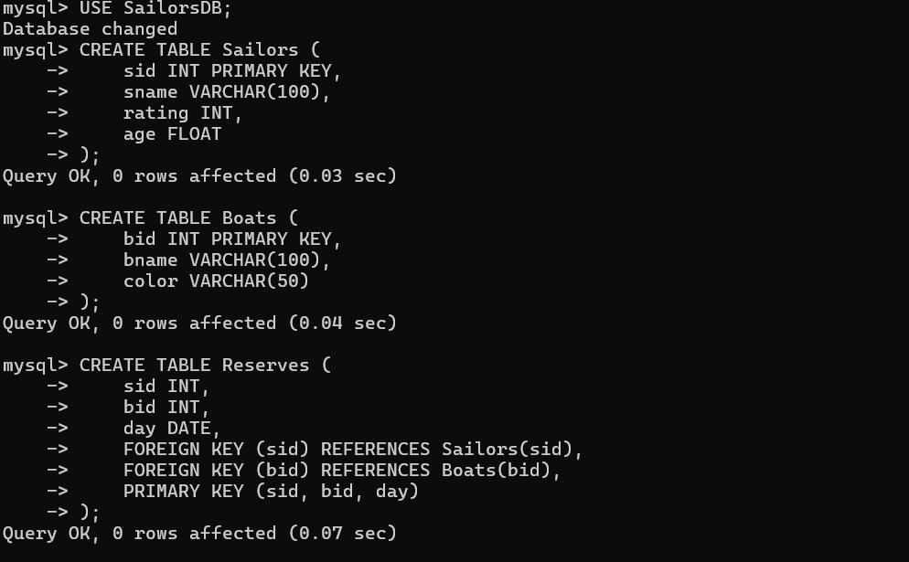

**b) Insert around 10 records in each of the tables.**

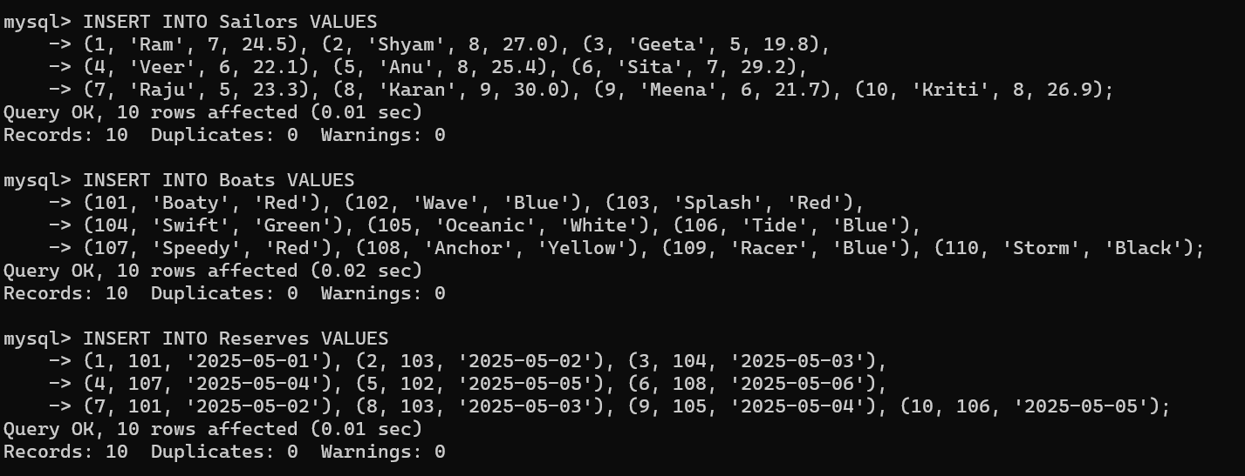

**c) Find the names of sailors who have reserved a red boat, and list in the order of age.**

**SELECT s.sname, s.age**

**FROM Sailors s**

**JOIN Reserves r ON s.sid = r.sid**

**JOIN Boats b ON r.bid = b.bid**

**WHERE b.color = 'Red'**

**ORDER BY s.age;**

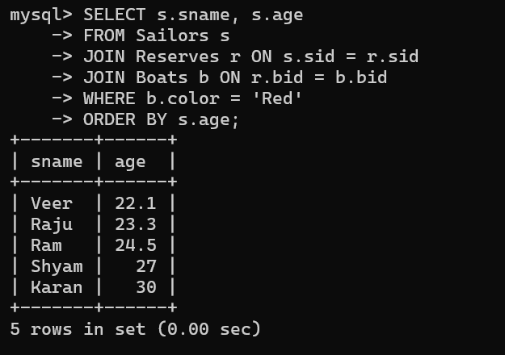

**d) Find the names of sailors who have reserved boat 103**

**SELECT s.sname**

**FROM Sailors s**

**JOIN Reserves r ON s.sid = r.sid**

**WHERE r.bid = 103;**

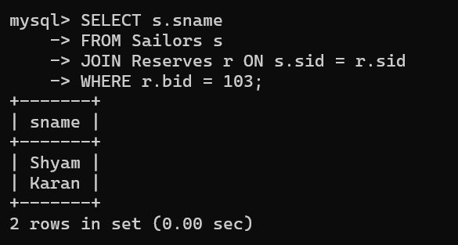

**e) Find the name and the age of the youngest sailor.**

**SELECT sname, age**

**FROM Sailors**

**WHERE age = (SELECT MIN(age) FROM Sailors);**

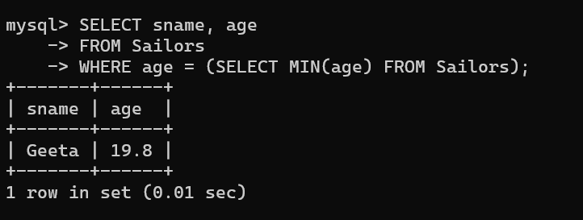

**f) Find the average age of sailors for each rating level that has at least two sailors.**

